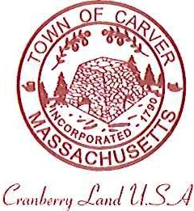
Carver Recreation Committee
Town Hall 108 Main Street
Carver, MA 02330

AGENDA

Date and Time: March 21, 2018
Location: Town Hall, Room 4

Approval of Minutes

Items for Discussion:
- Egg Hunt Saturday 3/24/18 / 11:00am
- Elementary School Yoga Classes
- April Vacation Programs: Wrestling? Dodge Ball, Science Class…Potion Lab $35, age K-2, minimum 8, max 12
- Spring Programs
Ready to post? Development stage?

Field Use Form:
- Fee
- Procedure to collect the fee
- Follow through/honor system with rosters
- Requests for field improvements

Discussion of Directorship Position: (Beginning Discussion)
- Job description
- Expectations/hours/purpose for position

Open Discussion with Team Representatives:
- Questions
- Concerns

