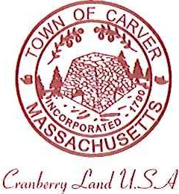
Carver Recreation Committee
Town Hall 108 Main Street
Carver, MA 02330

AGENDA

Date and Time: Monday, June 25, 2018….7:30pm
Location: Town Hall

Old Business
- Forest Street update
New Business

- Update Programs offered on Website
- Meeting with Youth Sports to collect all Rosters and Field Use Fees
Questions and concerns from the public

