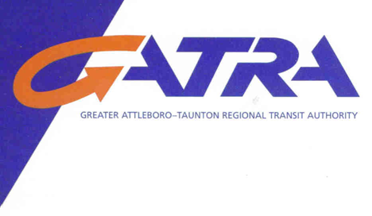

MEMO

To: GATRA Advisory Board Members and Designees
From: Mayor Thomas C. Hoye, Chairman of GATRA Advisory Board
Date: November 15, 2018
Subject: GATRA Advisory Board Meeting – Tuesday, Nov 20, 2018 @ 1 PM
Location: Stoneforge Publick House, Wellington Rm, 90 Paramount Drive, Raynham
___________________________________________________________________________

AGENDA

- Introductions

- Approval of June 13, 2018 Minutes

- FY2018 Financial Report - Discussion/Approval

- Weighted Vote Approval

- GATRA Status of Capital Projects & Service Update

- Legislative Update

- FY2019 Budget Revisions

- Public Hearings - Proposed Fare Increases
- Vote for Fare Changes on Fixed Route/Demand Response

- Proposed Service Changes

- SRPEDD Programs/Issues

- Other Business

PLEASE POST THIS NOTICE IN THE CLERK’S OFFICE OR ON TOWN BULLETIN BOARD

