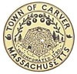
August 15, 2016
7:00 pm Meeting Room 4
Call to order
Review of minutes
Cole Bog
Farmers Market update
Fundraising
Educational Programs & target audiences
New Business
Old Business
Adjourn

