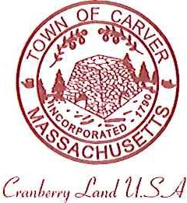
Carver Recreation Committee
Town Hall 108 Main Street
Carver, MA 02330

AGENDA for September 19, 2018

Approve minutes

Elections : Chairman, Vice-Chair, Social Media, Secretary
Vote to approve Emily to sign invoices, or continue with 3 signatures

Discussion Points: Procedure for acquiring a space to hold a Program
- Review last year’s Programs
- Create formula for paying instructors
- Review Summer Programs
- Fall Programs
- Halloween Event October 20th
- Winter Programs
- Idea for Winter or Spring….Pickle Ball League
- Forest St update
- Charity Tournament October 13 at King Property and Purchase st (11:30-dusk)
- Procedure for Field requests/update on School Committee meeting

Next meeting will address Youth Sports
Meeting Date:

