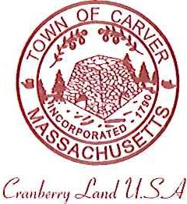
Carver Recreation Committee
Town Hall 108 Main Street
Carver, MA 02330

AGENDA

Date and Time: Wednesday, May16, 2018 at 6:15 pm
Location: Town Hall

Approval of minutes

Acceptance of Resignation from Lynn Doyle

Old Business:
- Field Scheduling updates
- Team roster and Fee requests
- Forest Street Field updates
- Spring/Summer Programs

New Business:
Open discussion of new position of Recreation Coordinator (or
title to be voted)

Schedule next meeting

