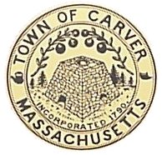
Cranberry Land USA
Carver Conservation Commission

Town Hall, 108 Main Street Telephone: 508-866-3482
Carver MA 02330 Fax: 508-866-3430

PUBLIC MEETING NOTICE
POSTED IN ACCORDANCE WITH THE PROVISIONS OF M.G.L. CHAPTER 30A SECTION 20 AMENDED
LOCATION OF MEETING: MEETING ROOM #1 – CARVER TOWN HALL, CARVER MA 02330

AGENDA for Wednesday, March 28, 2018
12:00 PM in the Conservation Office
AUTHORIZED PERSON - JIM NAUEN, CHAIR

ORDER OF BUSINESS

12:00 PM – Lot 4-A WENHAM ROAD

- Informal discussion on revised plans in regard to Lot 4A Wenham Road

