Carver Open Space and Recreation Plan
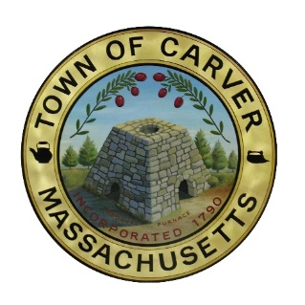
Steering Committee Meeting
AGENDA
December 7, 2022
4:30 p.m. – 6:00 p.m.
Meeting Room 1, Second Floor, Carver Town Hall
Posted in accordance with the provision of M. G. L. Chapter 30A, section 20b.

The Committee reasonably anticipates that the following matters will be discussed and / or voted on at this meeting:

- DISCUSSION ITEM: Results of public survey and in-person public engagement.
  - Presentation of outcomes and preliminary conclusions to inform plan goals, objectives, and action items, for questions specifically related to conservation and open space reservation.

- DISCUSSION AND VOTE ITEM: Public Plan Review
  - Discuss the merits of having the final public review session during a Planning Board meeting in late January.

- DISCUSSION ITEM: Next and final Committee meeting (Early Jan 2023) – topics and timing. Likely agenda items for next meeting include:
  - Vote on Committee acceptance of final plan document
  - Schedule the time and date of this Planning Board meeting

- Adjourn

